The Honorable ________
[Address Here] ________

November 13, 2017

Dear Representative _____,

As you know, the higher education community is expressly affected by the proposed tax reform bill - Tax Cuts and Jobs Act, introduced by the House Ways & Means Committee. The National Association of Graduate-Professional Students (NAGPS), is writing to share our views and concerns with you about this proposed bill, and to call for your support in opposing the provisions that impact members of the higher education community. NAGPS is a non-profit, student run, preeminent organization for graduate-professional students across the US. Since its inception in 1987, NAGPS has represented the interests of graduate-professional students in public and private universities at local, state, regional and national levels.

The House Tax Cuts and Jobs Act includes many provisions that not only adversely impact universities, but graduate students specifically. These provisions are:
- Repealing of provisions from the Tax Code:
  - Sec. 117(d)
  - Sec. 127
  - Student Loan Interest Deduction
  - The Hope Scholarship Credit & Lifetime Learning Credit
- Altering the American Opportunity Tax Credit to eliminate tax benefits for part-time students, graduate students and non-traditional students (who take more than five years to graduate)

Currently, Sec. 117(d) allows tax-free tuition remission for individuals employed as graduate-level teaching and research assistants. The proposed tax policy would lead to the elimination of the tax-free nature of tuition remissions, which will lead to a situation where students can barely survive on their stipends. Eliminating deductions for student loan interests and eliminating tax credits will also disincentivize higher education. Further, the repeal of Sec. 127 will limit the educational and professional growth opportunities of university employees that makes them competitive in this global economy.

During the mark-up period, an amendment to strike out Sec. 1204, increase the AOTC lifetime limit, and fix an inconsistency in tax code that would hurt recipients of Pell Grants was introduced by Representative Doggett (D-TX35). This amendment was voted down, leaving graduate students, part-time students and non-traditional students in peril. The impact of the Tax Cuts and Jobs Act will be felt by universities and graduate students on many levels. Ultimately, we ask for your support for the continued improvement of the American higher education system. We ask you to publicly oppose these provisions of the bill that will negatively impact the entire higher education community, and vote against these provisions on the floor of the House.

With Warmest Regards,

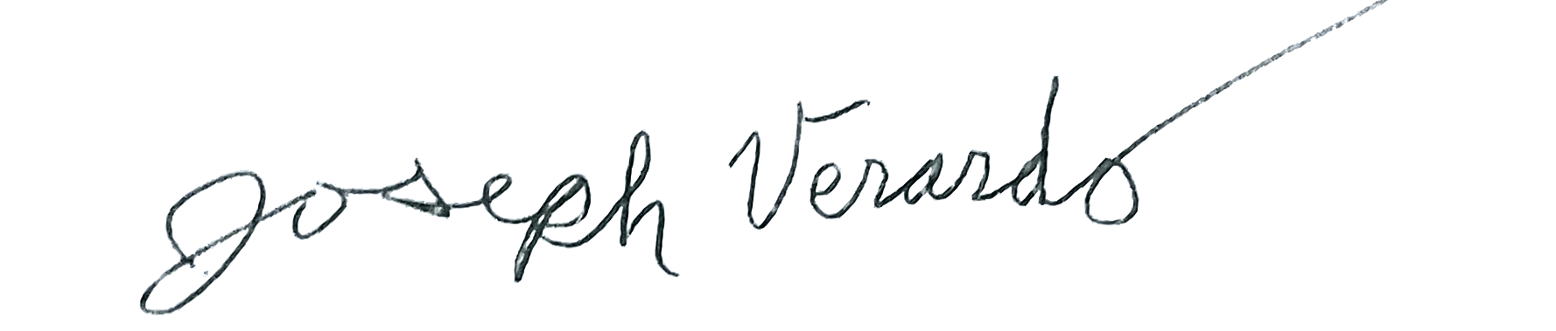
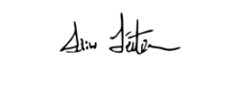
Sam Leitermann-Long Joseph Verardo
President, NAGPS Vice President, NAGPS

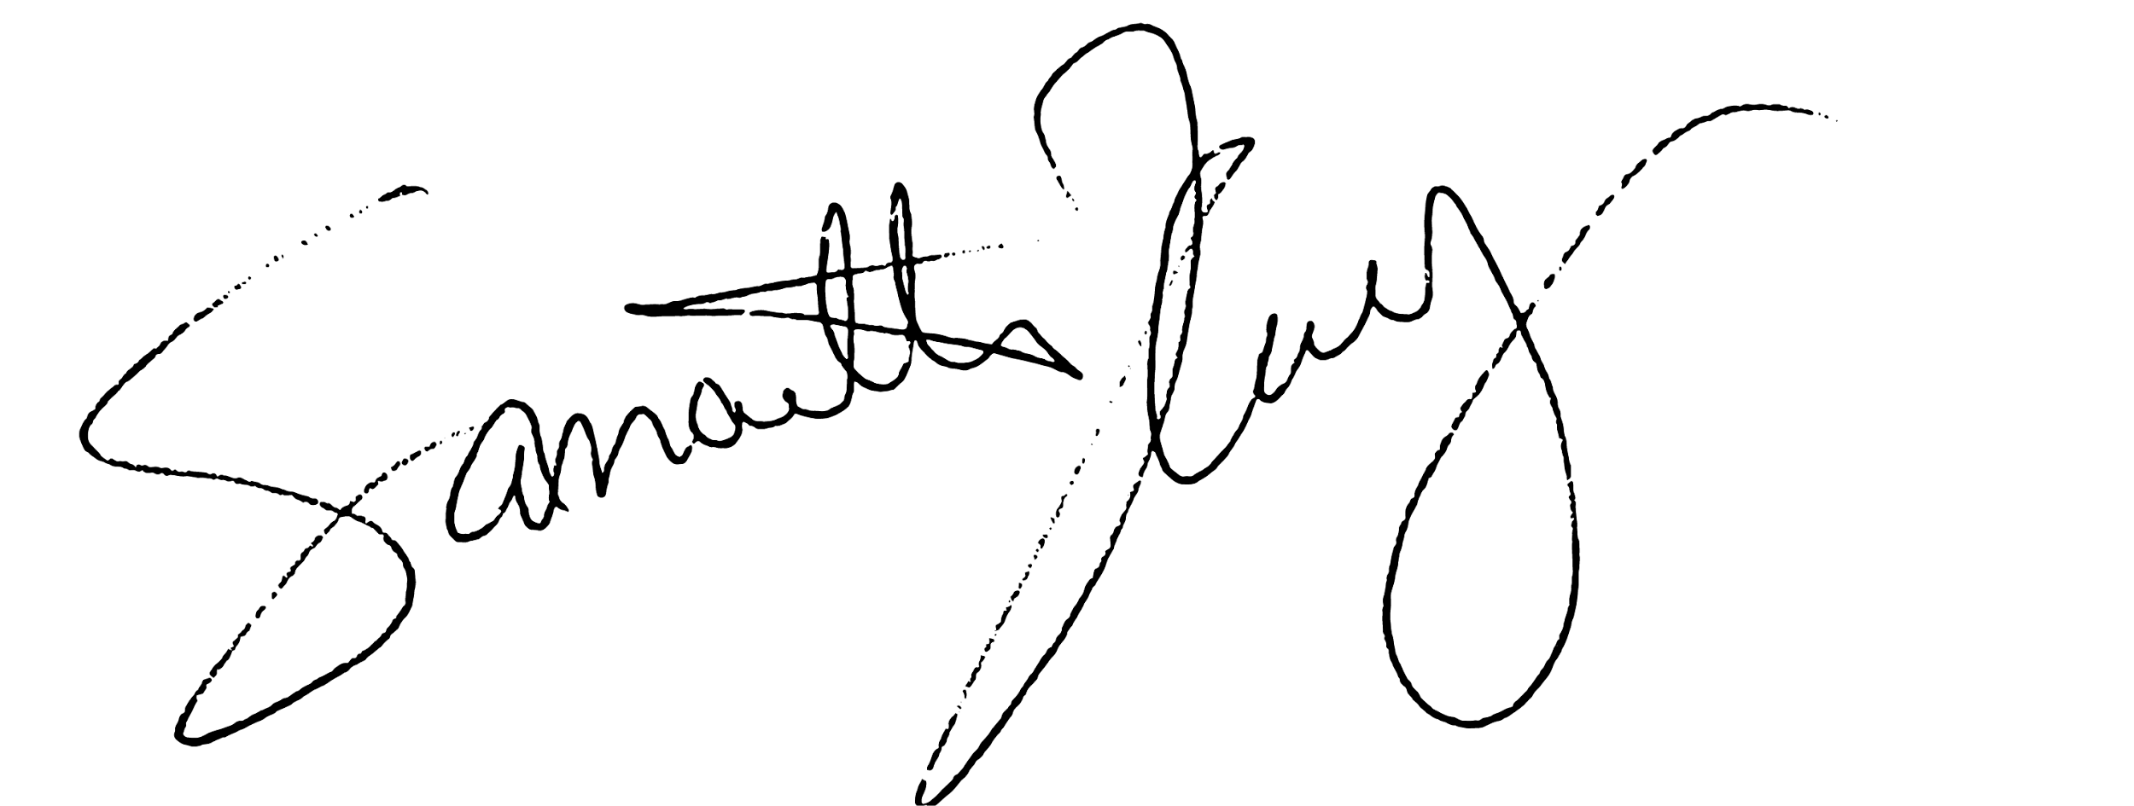
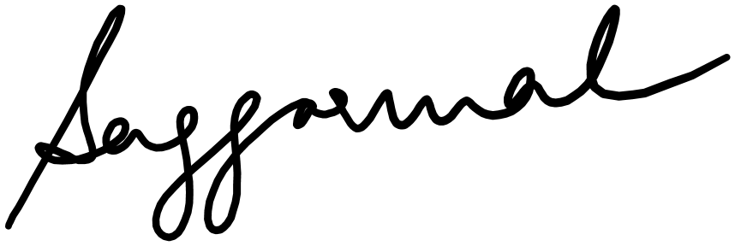

Samantha Hernandez Surya D. Aggarwal
Director of Legislative Affairs, NAGPS Chair of Advocacy Board, NAGPS

